Tony Novak, MBA, CPA, MT
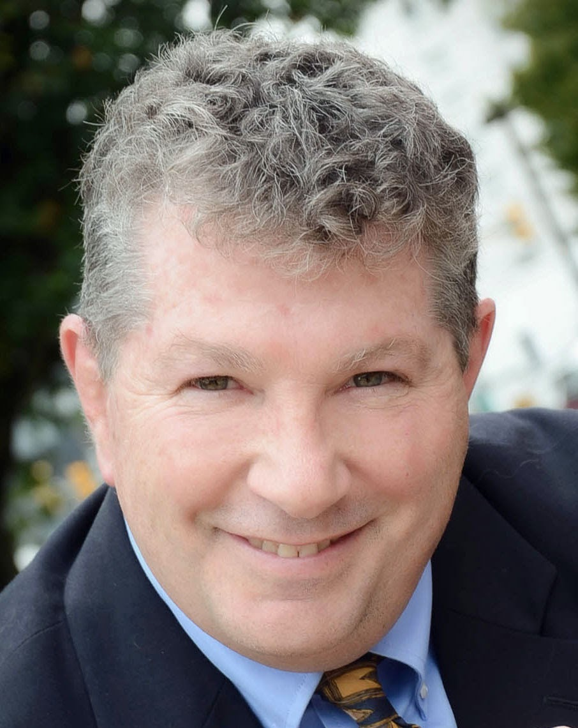

Tony Novak is a serial small business entrepreneur in the Philadelphia area. He founded MedSave, a first-generation insurance exchange later sold to a public company, and Freedom Benefits™, a tech-based firm with a personal, professional feel. He is a graduate of Delaware Valley University (BS, 1982), Temple University (MBA in Finance and Accounting, 1985) and Villanova Law School (MT, Compensation Planning, 1995). After a short career on Wall Street, he primarily served clients in the building trades, including a term on the board of the National Association of the Remodeling Industry. His businesses range from sweet corn farming, seafood, real estate, and a marina. Now his passion is promoting rural business redevelopment in South Jersey, promoting tax-free small business investments in restorative aquaculture, sustainable fishing, and waterfront recreation. He operates a sole practitioner CPA firm steps from the beach at Money Island, New Jersey that serves other entrepreneurs and investors. www.tonynovak.com

